JINSI YA KUJIUNGA NA MFUMO WA SALARY SLIP (SALARY SLIP PORTAL) KWA WATUMISHI.
Step 1. Fungua browser yoyote eg. Mozila firefox, google chrome, internet explorer….etc
Step 2. Andika https://salaryslip.mof.go.tz, mfumo utafunguka kama picha inavyoonesha.
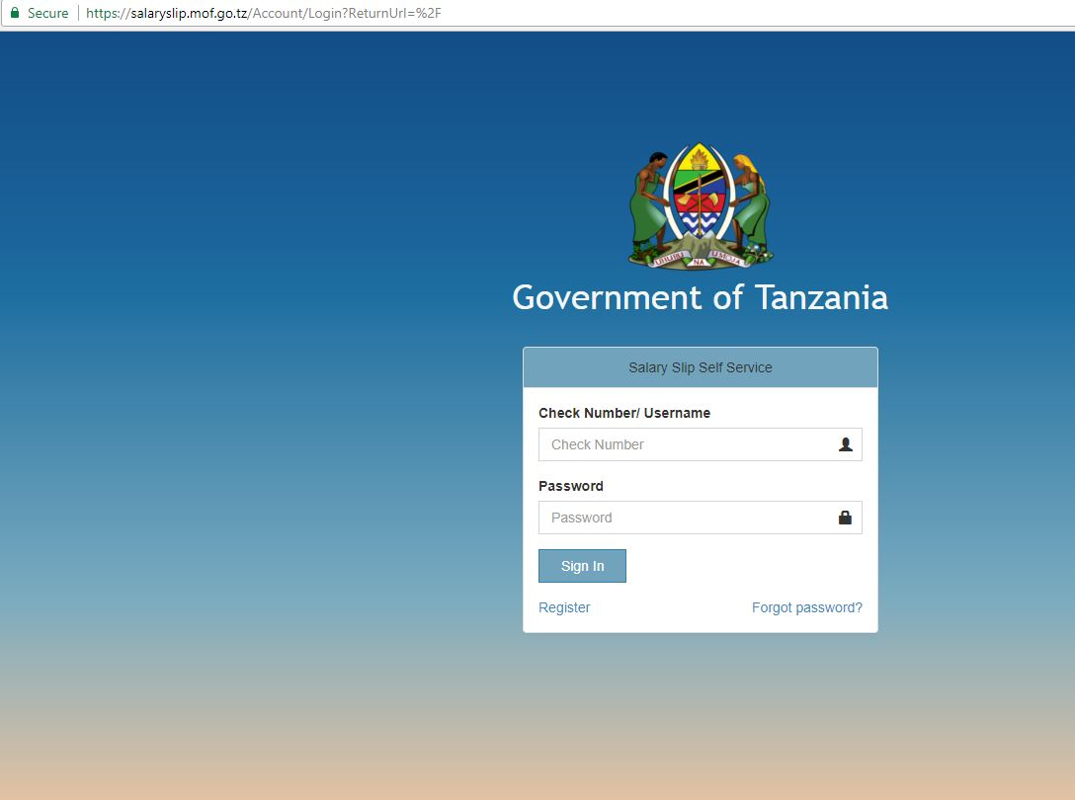
Step 3. Bonyeza “register” kwa ajili ya kujisaliji katika mfumo
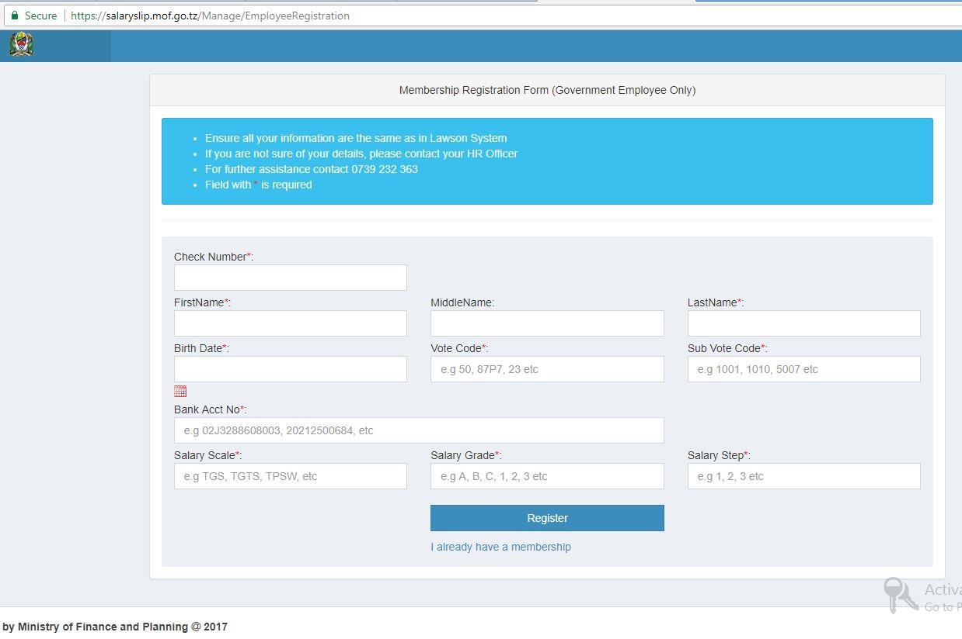

Step 4. Jaza taarifa zako binafsi katika kila chumba kwa kufuata maelekezo yafuatayo kisha bonyeza “register” kuendelea na hatua nyingine.
Taarifa zinazohitajika katika kujiunga na mfumo wa salary slip
- Check number
- First name
- Middle name
- Last name
- Birth date
- Vote code, mfano 86U1
- Sub vote code, mfano 5004
- Bank account namba
- Salary scale mfano TGS,
- Salary grade Mfano A, B, C, D, E, F….
- Salary step mfano 1, 2, 3..
**NOTE** Taarifa zako zote zifanane na zilizopo katika mfumo wa LAWSON.

Step 5. Ingiza namba ya simu, barua pepe (email address), neno siri(password), rudia tena kuandika neno siri (confirm password), Mwisho bonyeza “register” kukamilisha usajili.
